**Hands on 1**

**Create a Spring Web Project using Maven** 

**SpringLearnApp.java**

package com.cognizant.spring_learn;

import org.slf4j.Logger;

import org.slf4j.LoggerFactory;

import org.springframework.boot.SpringApplication;

import org.springframework.boot.autoconfigure.SpringBootApplication;

@SpringBootApplication

public class SpringLearnApplication {

private static final Logger LOGGER = LoggerFactory.getLogger(SpringLearnApplication.class);

public static void main(String[] args) {

SpringApplication.run(SpringLearnApplication.class, args);

LOGGER.info("SpringLearnApplication started successfully!");

}

}

P**om.xml**

<?xml version="1.0" encoding="UTF-8"?>

<project xmlns="http://maven.apache.org/POM/4.0.0" xmlns:xsi="http://www.w3.org/2001/XMLSchema-instance"

xsi:schemaLocation="http://maven.apache.org/POM/4.0.0 https://maven.apache.org/xsd/maven-4.0.0.xsd">

<modelVersion>4.0.0</modelVersion>

<parent>

<groupId>org.springframework.boot</groupId>

<artifactId>spring-boot-starter-parent</artifactId>

<version>3.5.3</version>

<relativePath/>

</parent>

<groupId>com.cognizant</groupId>

<artifactId>spring-learn</artifactId>

<version>0.0.1-SNAPSHOT</version>

<name>spring-learn</name>

<description>Demo project for Spring Boot</description>

<url/>

<licenses>

<license/>

</licenses>

<developers>

<developer/>

</developers>

<scm>

<connection/>

<developerConnection/>

<tag/>

<url/>

</scm>

<properties>

<java.version>17</java.version>

</properties>

<dependencies>

<dependency>

<groupId>org.springframework.boot</groupId>

<artifactId>spring-boot-starter-web</artifactId>

</dependency>

<dependency>

<groupId>org.springframework.boot</groupId>

<artifactId>spring-boot-devtools</artifactId>

<scope>runtime</scope>

<optional>true</optional>

</dependency>

<dependency>

<groupId>org.springframework.boot</groupId>

<artifactId>spring-boot-starter-test</artifactId>

<scope>test</scope>

</dependency>

</dependencies>

<build>

<plugins>

<plugin>

<groupId>org.springframework.boot</groupId>

<artifactId>spring-boot-maven-plugin</artifactId>

</plugin>

</plugins>

</build>

</project>

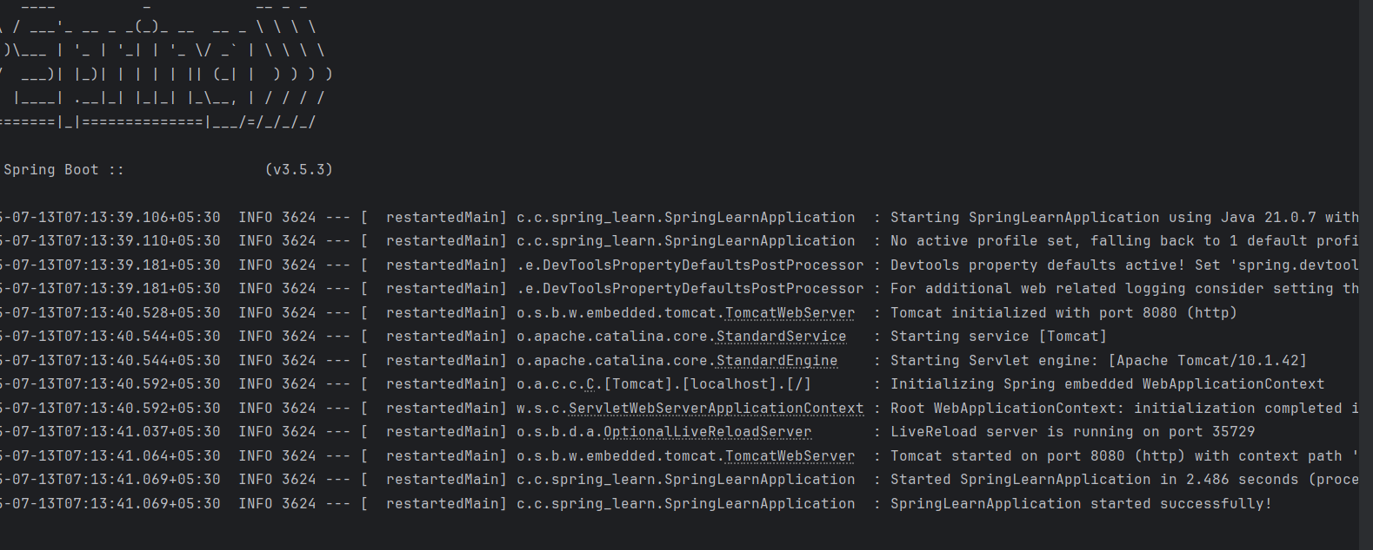

**Hands on 2**

**Spring Core – Load SimpleDateFormat from Spring Configuration XML** 

**DateFormatApp.java**

package com.cognizant.datefordemo;

import org.springframework.context.ApplicationContext;

import org.springframework.context.support.ClassPathXmlApplicationContext;

import java.text.ParseException;

import java.text.SimpleDateFormat;

import java.util.Date;

public class DateFormatApp {

public static void main(String[] args) {

ApplicationContext context = new ClassPathXmlApplicationContext("date-format.xml");

SimpleDateFormat format = context.getBean("dateFormat", SimpleDateFormat.class);

try {

Date parsedDate = format.parse("31/12/2018");

System.out.println("Parsed Date: " + parsedDate);

} catch (ParseException e) {

System.out.println("Error parsing date: " + e.getMessage());

}

}

}

**DateFormat.xml**

<?xml version="1.0" encoding="UTF-8"?>

<beans xmlns="http://www.springframework.org/schema/beans"

xmlns:xsi="http://www.w3.org/2001/XMLSchema-instance"

xsi:schemaLocation="http://www.springframework.org/schema/beans

https://www.springframework.org/schema/beans/spring-beans.xsd">

<bean id="dateFormat" class="java.text.SimpleDateFormat">

<constructor-arg value="dd/MM/yyyy" />

</bean>

</beans>

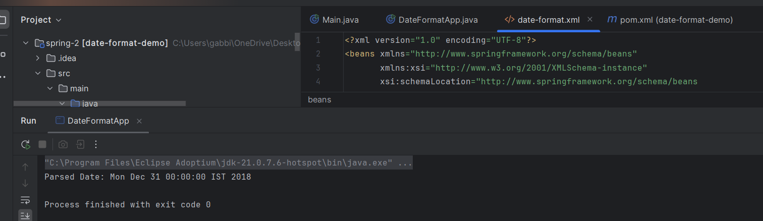

**Hands on 3**

**Spring Core - Incorporate Logging**

**DateFormat.java**

package com.cognizant.datefordemo;

import org.slf4j.Logger;

import org.slf4j.LoggerFactory;

import org.springframework.context.ApplicationContext;

import org.springframework.context.support.ClassPathXmlApplicationContext;

import java.text.ParseException;

import java.text.SimpleDateFormat;

import java.util.Date;

public class DateFormatApp {

private static final Logger LOGGER = LoggerFactory.getLogger(DateFormatApp.class);

public static void main(String[] args) {

System.setProperty("org.slf4j.simpleLogger.log.com.cognizant.datefordemo.DateFormatApp", "debug");

displayDate();

}

public static void displayDate() {

LOGGER.info("START");

ApplicationContext context = new ClassPathXmlApplicationContext("date-format.xml");

SimpleDateFormat format = context.getBean("dateFormat", SimpleDateFormat.class);

try {

Date date = format.parse("31/12/2018");

LOGGER.debug("Parsed Date: {}", date);

} catch (ParseException e) {

LOGGER.error("Error parsing date: {}", e.getMessage());

}

LOGGER.info("END");

}

}

**ApplicationProperties.xml**

logging.level.org.springframework=info

logging.level.com.cognizant.springlearn=debug

logging.pattern.console=%d{yyMMdd}|%d{HH:mm:ss.SSS}|%-20.20thread|%5p|%-25.25logger{25}|%25M|%m%n

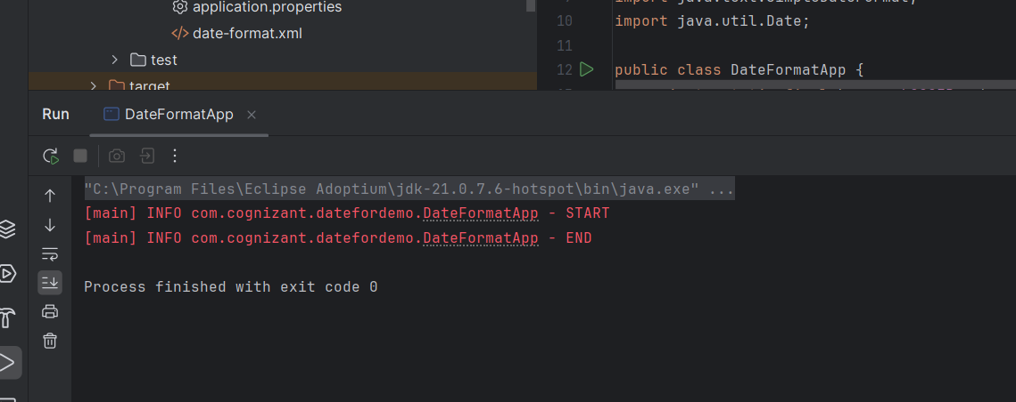

**Hands on 4**

**Spring Core – Load Country from Spring Configuration XML** 

**Country.xml**

<?xml version="1.0" encoding="UTF-8"?>

<beans xmlns="http://www.springframework.org/schema/beans"

xmlns:xsi="http://www.w3.org/2001/XMLSchema-instance"

xsi:schemaLocation="http://www.springframework.org/schema/beans

https://www.springframework.org/schema/beans/spring-beans.xsd">

<bean id="country" class="com.cognizant.springlearn.Country">

<property name="code" value="IN" />

<property name="name" value="India" />

</bean>

</beans>

Country.java

package com.cognizant.springlearn;

import org.slf4j.Logger;

import org.slf4j.LoggerFactory;

public class Country {

private static final Logger LOGGER = LoggerFactory.getLogger(Country.class);

private String code;

private String name;

public Country() {

LOGGER.debug("Inside Country Constructor.");

}

public String getCode() {

LOGGER.debug("getCode() called");

return code;

}

public void setCode(String code) {

LOGGER.debug("setCode() called");

this.code = code;

}

public String getName() {

LOGGER.debug("getName() called");

return name;

}

public void setName(String name) {

LOGGER.debug("setName() called");

this.name = name;

}

@Override

public String toString() {

return "Country{" +

"code='" + code + '\'' +

", name='" + name + '\'' +

'}';

}

}

**App.java**

package com.cognizant.springlearn;

import org.slf4j.Logger;

import org.slf4j.LoggerFactory;

import org.springframework.context.ApplicationContext;

import org.springframework.context.support.ClassPathXmlApplicationContext;

public class SpringLearnApplication {

private static final Logger LOGGER = LoggerFactory.getLogger(SpringLearnApplication.class);

public static void main(String[] args) {

System.setProperty("org.slf4j.simpleLogger.log.com.cognizant.springlearn", "debug");

displayCountry();

}

public static void displayCountry() {

LOGGER.info("START");

ApplicationContext context = new ClassPathXmlApplicationContext("country.xml");

Country country = context.getBean("country", Country.class);

LOGGER.debug("Country : {}", country.toString());

LOGGER.info("END");

}

}

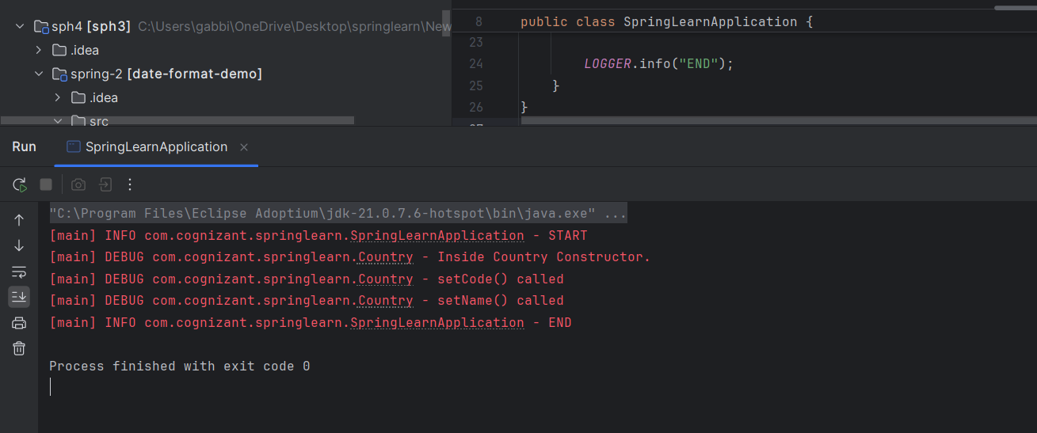

**Hands on 5**

**Spring Core – Demonstration of Singleton Scope and Prototype Scope** 

**Country.xml**

<?xml version="1.0" encoding="UTF-8"?>

<beans xmlns="http://www.springframework.org/schema/beans"

xmlns:xsi="http://www.w3.org/2001/XMLSchema-instance"

xsi:schemaLocation="http://www.springframework.org/schema/beans

https://www.springframework.org/schema/beans/spring-beans.xsd">

<bean id="country" class="com.cognizant.springlearn.Country" scope="prototype">

<property name="code" value="IN" />

<property name="name" value="India" />

</bean>

</beans>

**Country.java**

package com.cognizant.springlearn;

import org.slf4j.Logger;

import org.slf4j.LoggerFactory;

public class Country {

private static final Logger LOGGER = LoggerFactory.getLogger(Country.class);

private String code;

private String name;

public Country() {

LOGGER.debug("Inside Country Constructor.");

}

public String getCode() {

LOGGER.debug("getCode() called");

return code;

}

public void setCode(String code) {

LOGGER.debug("setCode() called");

this.code = code;

}

public String getName() {

LOGGER.debug("getName() called");

return name;

}

public void setName(String name) {

LOGGER.debug("setName() called");

this.name = name;

}

@Override

public String toString() {

return "Country{" +

"code='" + code + '\'' +

", name='" + name + '\'' +

'}';

}

}

**Application.java**

package com.cognizant.springlearn;

import org.slf4j.Logger;

import org.slf4j.LoggerFactory;

import org.springframework.context.ApplicationContext;

import org.springframework.context.support.ClassPathXmlApplicationContext;

public class SpringLearnApplication {

private static final Logger LOGGER = LoggerFactory.getLogger(SpringLearnApplication.class);

public static void main(String[] args) {

System.setProperty("org.slf4j.simpleLogger.log.com.cognizant.springlearn", "debug");

displayCountry();

}

public static void displayCountry() {

LOGGER.info("START");

ApplicationContext context = new ClassPathXmlApplicationContext("country.xml");

Country country = context.getBean("country", Country.class);

Country anotherCountry = context.getBean("country", Country.class);

LOGGER.debug("Country : {}", country);

LOGGER.debug("Another Country : {}", anotherCountry);

LOGGER.debug("HashCode country : {}", System.identityHashCode(country));

LOGGER.debug("HashCode another : {}", System.identityHashCode(anotherCountry));

LOGGER.info("END");

}

}

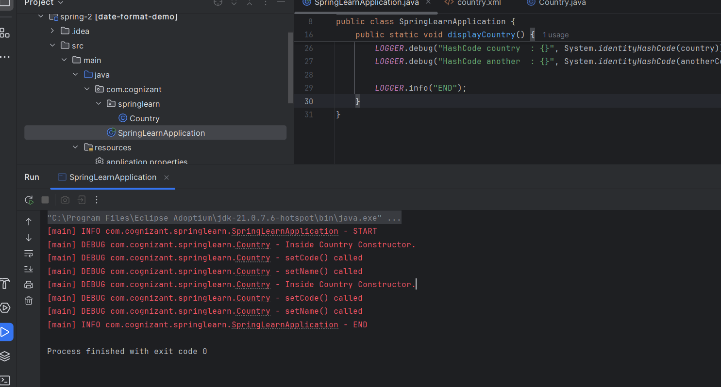

**Hands on 6**

**Spring Core – Load list of countries from Spring Configuration XML** 

**Country.xml**

<?xml version="1.0" encoding="UTF-8"?>

<beans xmlns="http://www.springframework.org/schema/beans"

xmlns:xsi="http://www.w3.org/2001/XMLSchema-instance"

xsi:schemaLocation="http://www.springframework.org/schema/beans

https://www.springframework.org/schema/beans/spring-beans.xsd">

<bean id="in" class="com.cognizant.springlearn.Country">

<property name="code" value="IN"/>

<property name="name" value="India"/>

</bean>

<bean id="us" class="com.cognizant.springlearn.Country">

<property name="code" value="US"/>

<property name="name" value="United States"/>

</bean>

<bean id="de" class="com.cognizant.springlearn.Country">

<property name="code" value="DE"/>

<property name="name" value="Germany"/>

</bean>

<bean id="jp" class="com.cognizant.springlearn.Country">

<property name="code" value="JP"/>

<property name="name" value="Japan"/>

</bean>

<bean id="countryList" class="java.util.ArrayList">

<constructor-arg>

<list>

<ref bean="in"/>

<ref bean="us"/>

<ref bean="de"/>

<ref bean="jp"/>

</list>

</constructor-arg>

</bean>

</beans>

**Country.java**

package com.cognizant.springlearn;

import org.slf4j.Logger;

import org.slf4j.LoggerFactory;

public class Country {

private static final Logger LOGGER = LoggerFactory.getLogger(Country.class);

private String code;

private String name;

public Country() {

LOGGER.debug("Inside Country Constructor.");

}

public String getCode() {

LOGGER.debug("getCode() called");

return code;

}

public void setCode(String code) {

LOGGER.debug("setCode() called");

this.code = code;

}

public String getName() {

LOGGER.debug("getName() called");

return name;

}

public void setName(String name) {

LOGGER.debug("setName() called");

this.name = name;

}

@Override

public String toString() {

return "Country{" +

"code='" + code + '\'' +

", name='" + name + '\'' +

'}';

}

}

**Application.java**

package com.cognizant.springlearn;

import org.slf4j.Logger;

import org.slf4j.LoggerFactory;

import org.springframework.context.ApplicationContext;

import org.springframework.context.support.ClassPathXmlApplicationContext;

import java.util.List;

public class SpringLearnApplication {

private static final Logger LOGGER = LoggerFactory.getLogger(SpringLearnApplication.class);

public static void main(String[] args) {

System.setProperty("org.slf4j.simpleLogger.log.com.cognizant.springlearn", "debug");

displayCountries();

}

public static void displayCountries() {

LOGGER.info("START");

ApplicationContext context = new ClassPathXmlApplicationContext("country.xml");

List<Country> countryList = context.getBean("countryList", List.class);

for (Country country : countryList) {

LOGGER.debug("Country : {}", country.toString());

}

LOGGER.info("END");

}

}

